Committee Report: Legislation
Submitted By: Janene Johnstone
Date Submitted: 4-29-18

All of these changes are effective as of 6-7-18, unless otherwise noted.

Relevant to MPA Membership:

SHB 1524 – Regarding therapeutic courts (specifically, drug courts, I believe), clarifies what the funds in the Criminal Justice Treatment Account can and can’t be used for: for “treatment and recovery support services for criminally involved offenders and authorization of these services shall not be subject to determinations of medical necessity;” removes language that previously included “administrative and overhead costs associated with the operation of a drug court”.

E2SHB 1783 – Prohibits jurisdictions from charging interest on “nonrestitution legal financial obligations” (this does not apply once it gets sent to collections). The wording is confusing, however, because later it says that “penalties, fines, bail forfeitures, fees, and costs imposed against a defendant in a criminal proceeding shall not accrue interest,” and the way this section is situated in the language seems to imply that this is the case whether the balance is in collections or not. This bill also talks about not ordering costs if a defendant meets the criteria of indigent at the time of sentencing, talks about installment payments and converting to community service. Sanctions cannot be imposed for failure to pay if there is a hearing and the failure to pay is not found to be willful.

SHB 2752 – Regarding search warrants, “If the jurisdiction of a district or municipal court encompasses all or part of more than one county, a judge for that district or municipal court may issue a search warrant for any person or evidence located anywhere within the state as long as the county in which the offense is alleged to have occurred is one of the counties encompassed within that court’s jurisdiction.”

HB 2892 – Directs WASPC to “develop and implement a mental health field response grant program,” in order to “assist local law enforcement agencies to establish and expand mental health field response capabilities.” Discusses some provisions of the grant application process and what the response teams should consist of.

SB 5987 – Get ready to start doing pretrial UA’s again! Specifically allows for pretrial prohibition of drug or alcohol use, and indicates that the court can “require the defendant to submit to testing to determine the defendant’s compliance with this condition, when the judicial officer determines that such condition is necessary to protect the public from harm.”
ESSB 6491 – Some portions were effective 4-1-18, other portions are effective 6-7-18, and others 7-1-18 – Makes modifications to the involuntary treatment act.
- Changes the term “in need of assisted outpatient mental health treatment” to “in need of assisted outpatient behavioral health treatment” and includes a person with a substance use disorder
- Less restrictive alternative treatment services
- Establishes a process for initial evaluation and filing of a petition for assisted outpatient behavioral health treatment
- Designated crisis responders
- Outlines procedures for additional treatment
- Discusses conditional release orders
- Covers revocation proceedings and court orders for detention for inpatient treatment and for assisted outpatient behavioral health treatment

Also of Possible Interest:

SHB 1022 – Establishes some protection to immigrant victims

ESHB 1047 – Establishes a prescription drug take-back program

2SHB 1298 – Prohibits employers from asking about arrests or convictions until after they’ve determined whether an applicant is otherwise qualified for the position

2ESHB 1388 – Effective 7-1-18 – Transfers the designation of the state behavioral health authority from DSHS to the Health Care Authority and the Department of Health

E2SHB 1889 – Establishes the Office of the Corrections Ombuds within the Governor’s office, “to assist in strengthening procedures and practices that lessen the possibility of actions occurring within the department of corrections that may adversely impact the health, safety, welfare, and rehabilitation of offenders, and that will effectively reduce the exposure of the department to litigation.”

SHB 2016 – Requiring that “reasonable accommodations” be made for providing midwife or doula services “to inmates who are pregnant or who have given birth in the last six weeks.”

HB 2638 – Outlines specifics for the graduated re-entry program for DOC.

HB 2661 – Protects against employment discrimination for actual or perceived victims of domestic violence, sexual assault, or stalking.

EHB 2759 – Establishes the “Washington State Women’s Commission” in the office of the Governor. “The commission shall address issues relevant to the problems and needs of women, such as domestic violence, child care, child support, sexual discrimination, sexual harassment, equal compensation and job pathways opportunities in employment, and the specific needs of women of color.”

E2SSB 6160 – Effective 6-7-18, portion effective 7-1-19 – Clarifies extension of juvenile court jurisdiction in certain circumstances, for certain felony offenses.

SSB 6222 – Effective 7-1-18 – Changes the extended foster care age from 19 to 21.

SB 6582 – Similar to 2SHB 1298, which prohibits employers from asking about arrests or convictions until after an applicant has been otherwise determined qualified for the position, this bill prohibits institutions of higher education from requesting criminal history information on the initial admissions application, and cannot consider criminal history information until after determining that an applicant has “otherwise been determined to be qualified for admission.”

Also, out of last year’s legislative session came HB 1163, which established work groups to look at a DV Risk Assessment tool, and DV Perpetrator Treatment. Bree Breza from Airway Heights and Koa Lee with Pierce County stepped up to represent MPA at those work groups.

Concurrently, Tonya Dotson with Seattle Municipal Court was involved in the work group that worked on a major overhaul to our state’s DV treatment requirements. If you’re up for a little light reading, it’s only 60 pages long, and can be found at Chapter 388-60A WAC. The process will mirror chemical dependency in that there will be an assessment and different levels of treatment, based on certain criteria. Amie Roberts with DSHS is working on making the rounds statewide to provide training on the upcoming proposed changes, and Tonya is also a wealth of information. It is my understanding that there was a public hearing on 4-24-18 and the final paperwork is being submitted to DSHS for approval.

**Updated 5-11-18**

Keep an eye on SB 6370 – Would change the retirement age for PSERS from 60 to 57, in order to maintain the 5-year difference in retirement ages between PERS and PSERS.

This bill does not appear to have gained much momentum since its introduction earlier this year, but it looks like there’s hope for it heading into the 2019 legislative session. There is a work session scheduled for 10:00 on May 15th in Olympia, during which the public may be allowed to testify. See details below:

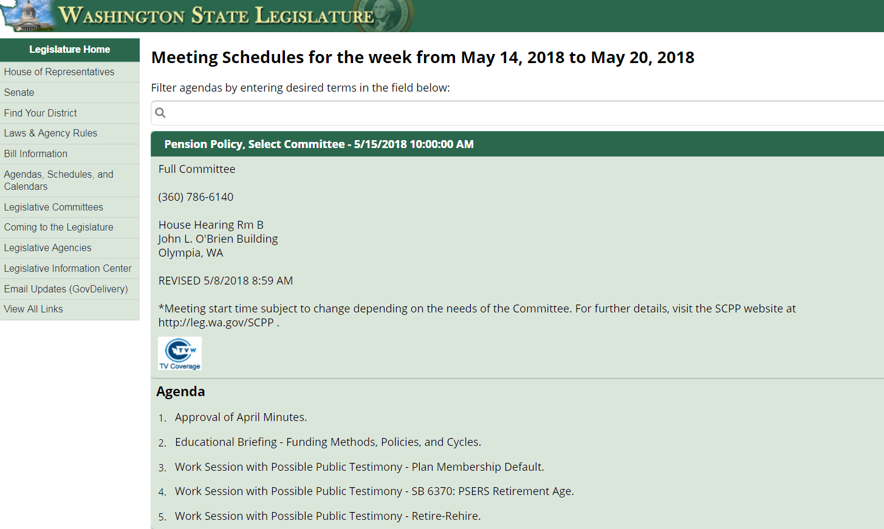

Next Meeting Date: July 2018

Committee Contact Name: Janene Johnstone
E-Mail: jjohnstone@kentwa.gov

Please e-mail a copy of your report to Camille Jackson at CJackson@lynnwoodwa.gov. Thank you.

