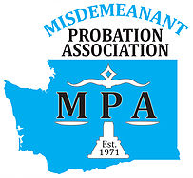
MPA MEMBERSHIP FORM
Washington State Misdemeanant Probation Association
MPA Tax ID # 91-1254334

Professional Member ($40.00)  Renewal  New
Those employed in a Court or government organization.
Such as officers, counselors, clerks and court coordinators.
Associate Member ($10.00)  Renewal  New
Limited to students, retirees or those outside government.

Date: ____________________________________________

First Name
Last Name
Title
Organization
Street Address
Address (cont)
City/State/Zip
County
Work Phone
FAX
Email
Jurisdictions Served
Mark the appropriate categories  in which you are interested in  helping out, if needed? |  |  Legislative   Membership   Education   Newsletter
Number of years in probation
Member of MPA since

Membership is good for one year in the calendar year that it is paid.

.
Example:
If you pay in January of 2019 your membership is valid until December 31, 2019
If you pay in November of 2019, your membership is valid until December 31, 2019

Please fill out form, include a check payable to MPA and mail to:

Mindy Breiner, MPA Treasurer
Tukwila Municipal Court-Probation
6200 Southcenter Blvd
Tukwila, WA 98188

