NOVEMBER-DECEMBER 2017
MPA QUARTERLY
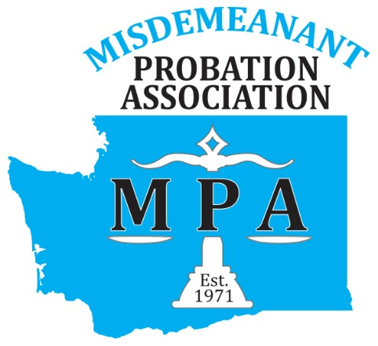

Upcoming Events

January 21
APPA WINTER INSTITUTE-HOUSTON

February 12
MPA BOARD MEETING-ELLENSBURG

April 23
WTSC-ANNUAL CONFERENCE KENNEWICK

Important Announcements
Updated membership forms are available on the website! Please renew your membership in January prior to registering for the annual conference!
WWW.WAMCA.ORG/MEMBERSHIP
Additionally, consider enrolling American Probation and Parole Association for added benefits.
WWW.APPA-NET.ORG
Last year’s conference materials will disappear from the website as of 12/29/17. Be sure to download and save the presentations you want. We’re making room for the new materials!

WWW.WAMCA.ORG
Thank you for another great year! It has been filled with changes on our end. If you recall we held a vote to change our name earlier in the year! Almost unanimously all voted to become Misdemeanant Probation Association! If you have visited the website you would have seen our new logo designed by a local company, CocoaSweet Designs! Additionally, with the name change comes updating MCA to MPA with the state; the IRS and in the By-laws! You would be surprised how many times MCA needs to be changed to MPA on all the documents!
We look forward to 2018! Please consider joining the board, attending the annual conference and sharing your voice.
On behalf of the board, enjoy your holiday season! May the revocations be few, the compliances be many and all probation officers be happy.
NEWS
- Chris Hornung-MPA Vice-President will be attending the American Probation and Parole Association Winter Institute in January on behalf of MPA. We look forward to her sharing all that is learned with the rest of MPA.
- Spokane Municipal Court and Des Moines Municipal Court will be starting DUI Courts in 2018. Each court was recently awarded DUI Court Candidate Court status with the Washington Traffic Safety Commission. If your court is interested in starting a DUI Court more information about the DUI court model and training can be found at WWW.DWICOURTS.ORG
- Planning for the Annual Conference is well under way! There are many great speakers coming our way. Our education chairs are looking for potential vendors/sponsors. If you work closely with an agency that you would like to be considered please forward information to Chris Allen and Jim Smallwood.

WORTHWHILE READING

Case Asks If It's Constitutional To Require Someone On Probation To Remain Drug-Free

Two arrested for attempted murder of South Carolina probation officer
