MPA Quarterly Board Meeting
October 18,2021
Hybrid Meeting

Attendees: Melissa Patrick, President; Jennifer Crossen, Vice-President; Cathy Oakes, Past-President; Mindy Breiner, Treasurer; Omar Gamez, Education and Training Co-chair; Janene Johnstone, Legislative; Djanette Apilado, Nominations; Kristine Nisco, Technology; Melanie Vanek, Public Relations; Vicky Cullinane, AOC; Regina Alexander, DMCJA liaison (ours), Trish Kinlow, DMCMA liaison; Debbie Johnson, DMCMA liaison (ours)

Speakers: Paulette Revoir, Cat Robinson, and Jennifer Wagner

Absent: Honorable Lisa Leone, Paige Sprague, Camille Jackson

10:08 Melissa declares Quorum, calls meeting to order and welcomes all that are present

Review of meeting minutes: Cathy motions to approve, Jen seconds, no discussion, minutes are approved unanimously

Special Presenters: Jennifer Wagner/Cat Robinson AOC CLJ-CMS project
- Project is going well
- AOC is working closely with courts
- Pilot Court Implementation is running as scheduled
- Working to combine Tyler Supervision and Odyssey
- Probation Focus Group is VERY helpful.
- The Data conversion is going well. They have completed 5 conversions so far for the pilot courts
Cat states the AOC CLJ-CMS newsletter is out there and that they would be more than happy to promote MPA and staff. No questions from the board. Melissa thanks them for their work.

Courts helping Courts: Paulette Revoir/Trish Kinlow
- Began approx. 20-30 years ago when onboarding JIS
- 2015 revived programs for CLJ-CMS project and data clean-up
- Purpose: As the name implies, the program was designed to give support and help to CLJ’s in WA State.
- Services Provided:
  - Everything from training new management and staff coverage help to data conversion and higher-level support
  - Mentorship Program:
    - New manager meets with a seasoned manager for guidance and as a point of contact for questions/feedback and to introduce to area managers to broaden support.
- Committee Structure:
  - Chair and Vice Chair
  - Member for each region of state
- Things to consider:
  - Budget: Mileage/hotel if needed
    - Remote if possible
  - Approval from Probation Manager/Court Administrator
Question from Mindy: How to budget for this program? DMCMA Treasurer Judy Lee looked at their Budget vs Actual and found line items that were hardly used and moved money from one line item to this budget. Traditionally, they do not exceed their budget, but this year they have had a few courts that are new and need additional support as well as the CLJ-CMS project that are taking up the budget for CHC’s.

Melissa has the packet of information and if there are any questions from your administrators regarding the CHC and why MPA could benefit from their own, you can send them to Trish.

Board Reports:

President’s Report: Melissa welcomes all members.
- Debbie Johnson will retire before our next board meeting. Board congratulates her on retirement.
- By-laws updated: MPA membership approved increase of membership positions from one year to two years.
- APPA Summer Training Institute update
  - Melissa discussed ways for MPA to work closely with American Probation and Parole Association. She states Washington has a new APPA rep, Michael DiGuilio (Community Corrections Officer)
  - Currently only 35 memberships to APPA in Washington state. That is both individual and agency combined. Would like to increase this as Washington has the lowest APPA membership.
  - Melissa would like an AD HOC liaison between MPA and APPA and proposed to add that role on the duties of the Vice-President
  - Jen will go to Winter APPA Training Institute in Atlanta
  - Currently APPA is offering two for one membership fees
  - APPA is currently offering some free online education opportunities

Vice-President’s Report: Jen agreed with Melissa’s proposal for the position to act as liaison between MPA and APPA. Nothing further to report

Past President Report: Cathy will be moving to Chelan to become the probation supervisor when Debbie retires.

Treasurer’s report: Mindy presented the updated budget report. Motion to approve report Janene, 2nd Jen; no discussion, report approved unanimously.

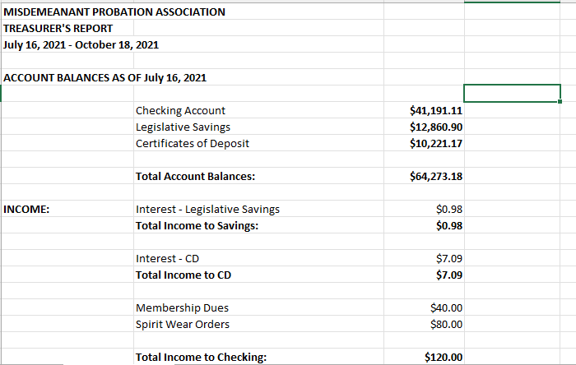

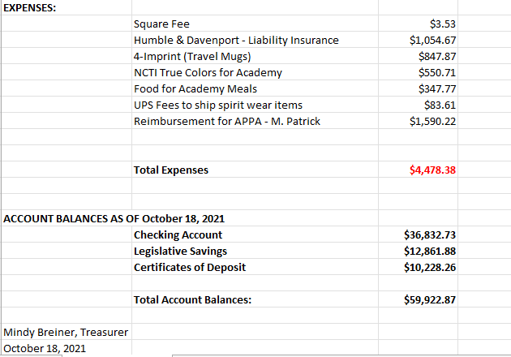
Secretary Report: Camille excused from meeting. Jen and Melanie are taking notes for today.

Legislative report: The 2013 meta-analysis of DVBT programs was not exactly glowing; however, a recent comparable study was done for DV-MRT and you can find the preliminary report and final presentation here. The preliminary summary was extremely promising:

Outcome Evaluation: The focus of the outcome evaluation was to examine if DV-MRT was meeting its intended goal of DV reconviction reduction. We utilized a rigorous quasi-experimental design and made use of a historical matched comparison group comprised of individuals who were released in King and Snohomish counties prior to the implementation of court-sponsored DV-MRT. Overall, the findings of the outcome evaluation are positive and indicate that participation in a DV-MRT program appears to reduce the likelihood of Any DV Reconviction (1-year: 8.4% versus 12.5%; 2-year: 14.9% versus 19.0%); only the results at 1-year follow-up were statistically significant. This differential pattern of recidivism between study groups demonstrates that the DV-MRT program appears to increase public safety in preventing the reoccurrence of DV crimes committed in the short-term by court-involved individuals. This makes court-sponsored DV-MRT a promising program considering its much lower costs compared to traditional DV treatment.

The DMCJA was kind enough to loop me back into their legislative committee meetings; however, somehow I’ve managed to be on vacation for all of them so far. I look forward to finally being able to attend the next one on 11-12-21. I have been sent their meeting agendas and it appears that they are working on trying to address some issues that arose out of E2SHB 1320’s passing this last legislative session, which attempts to modernize, harmonize, and improve the accessibility of the laws concerning civil protection orders (for example, technology limitations, lack of expertise/resources to compile and maintain resource lists, and no process in place for GALs in CLJs). Also, I believe Judge Larson is helping draft a model for the interlocal probation service agreement, but I don’t know anything more at this time. Have any departments started utilizing this yet?

In addition, there is a work group that is hoping to have our DP law updated / revised. Julie Mitchell was kind enough to pass along some information regarding those proposed changes, including eligibility. Some changes being tossed around are: allowing one every 5 years, vs. one in a lifetime, vs. being eligible for a 2nd DP but only if they had one for their 1st DUI (can’t “save it for your second DUI”); updating language; having to demonstrate amenability before DP is granted by being in treatment for 14 days beforehand; updates treatment plan requirements. Next meeting of this work group is this Friday, 10-22-21.

As always, if you hear of something you’d like me to look into, let me know!
Next Meeting Date: 1-24-22
Committee Contact Name: Janene Johnstone E-Mail: jjohnstone@kentwa.gov

Nominations Report: JoAnna excused from meeting- no updates at this time.

Membership Report: Djanette stated she had made an update to the directory and will send it out to get further editing/corrections/updates. Membership forms will go out in mid-December.

Technology Report: Kristine reports the CLJ-CMS continues to progress and move forward. The Steering Committee has increased meetings to twice a month as the project picks up.

Administrative Office of the Court: Also, covers CLUG/MCLUG report (Melanie and Kristine) Vicky reports that the only recent request was ITG request 256 from Spokane re integration for data upload from their CMS into the EDR. Analysis was conducted, Spokane agreed to submit a letter noting their commitment to taking on their responsibilities in the request, and it was approved. Upcoming is ITG request 265 from Kitsap who is making a similar request.

Looking for a volunteer to cover for when Debbie leaves the CUWG. Candidate will have experience with Tyler Supervision. Suggestions: Cathy, Jen, or Pat Gigstead.

Public Relations Report: Melanie is updating our website and social media sites with news, job openings and any kudos submitted to her. Would really like more kudos and highlights of what courts are doing. She did her first MPA swag give away on Facebook and it went really well. Always looking for other ideas. Cat Robinson added that they would work with MPA to get out any highlights on members/programs, should MPA wish to utilize that newsletter.

Washington Traffic Safety Commission Report: Melissa discussed updates to the Deferred Prosecution language. Notes that we were awarded a $20,000 grant to be used for PBT’s, update the supervision manual, and to pay for speakers/impaired driving trainings. She tasked Omar and Paige to find impaired driving programs to bring to the conference. Mindy made a motion to accept the grant and move forward with using funds, Cathy 2nd the motion, no discussion, motion passed unanimously.

District and Municipal Judges Association Report: Judge Leone excused. Our liaison to the DMCJA, Regina, noted there is no new interlocal DP agreement. She will be appearing at the November 12th meeting and to send concerns to her.

District and Municipal Court Managers Association Report: Trish stated the DMCMA conference will be May 14-18th and they are deciding if it will be virtual, live or a hybrid. She discussed upcoming trainings for all court staff. Trish states that it could benefit MPA to have a representative on the various commissions and boards around the state in order to have a voice and be proactive (i.e., the Minority and Justice Commission, amongst others). Melissa requested that Trish remind DMCMA membership of the MPA and the benefits for their probation department.

Criminal Justice Training Commission Report: Mindy states the academy was a success. 29 participants started and 28 graduated. The group was very diverse in experience and included two managers. MPA was not under contract with the CJTC, but there is a group at CJTC that is looking into this so that MPA academy is covered. Academy was hybrid this year. First week was virtual and the second week was in person at both the Tukwila Municipal Justice Center and at CJTC. Mindy did like the hybrid academy as she felt the participants were more comfortable with each other on their first day in person than they had been in the past.

Audio Visual Report: vacant. Melissa is requesting incentive ideas to get a person in this position. She states MPA gets charged if we use the hotel A/V person, but if we provide our own, then it is free to us. This is tabled.

New Business: Board discussed the Building Bridges name for MPA’s version of Courts Helping Courts. Feedback was positive and we will continue to move forward on this project.

Education and Training Report: Omar reported the committee needs ideas from presenters. Trish proposed reaching out to the various commissions to see if they have ideas on topics and presenters and gave him contact information (Gender and Justice, Minority and Justice, Interpreter Commission). Paige is working on securing vendors. Bryan is going to be helping out as a point of contact given he is in the area of the conference and will be able to assist with connections/hotel/accommodations. Will be looking into Impaired Driving related training to satisfy grant money requirements. Registration costs are being discussed.

Next meeting is 1/24/21 10 am- 12 pm and will be offered as hybrid again.

11:41 Meeting adjourned.

